ISTITUTO ISTRUZIONE SUPERIORE ENRICO FERMI CATANZARO LIDO
Rapporto narrativo Mobilità di gruppo a Izegem (Belgio) 17 - 24 Aprile 2023

ERASMUS + KA1

Hello everyone, we are Miriam, Sofia, Kenya, Sara and Angela, five students attending the “IIS Fermi” in Catanzaro Lido. Thanks to our school, this year, we had the chance to live an experience that changed our life: an Erasmus+ group mobility in Belgium.
The first meeting was in Italy, it was great to be able to meet many Belgian young people and be able to become friends.
One of the best moments was when our teacher told us that we would leave for Belgium; we were very excited about going abroad for the first time and seeing our friends again.

On April 17th our parents took us to Lamezia airport, where we had to meet with the other girls of our school and the teachers. We were nervous but also excited because, for most of us, it was the first travelling experience outside Italy. After hugging our parents, we got on board and the plane took off.
We left from Lamezia Terme to Bruxelles. When we landed we were afraid of not being able to communicate with the families that would host us, but, all these worries disappeared when we saw our Belgian friends that had took part in the first meeting in Italy.
Finally, in Izegem we met once again the guys and girls that we had hosted between February and March.

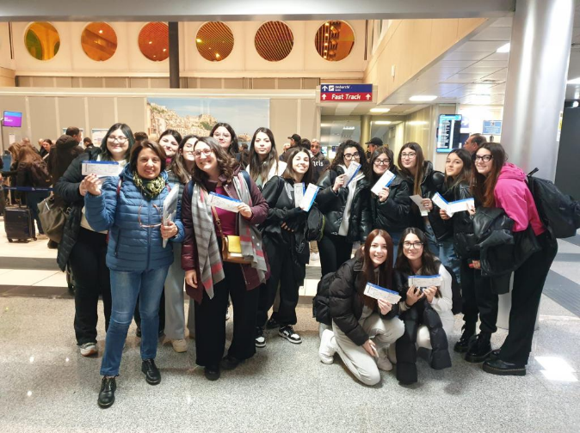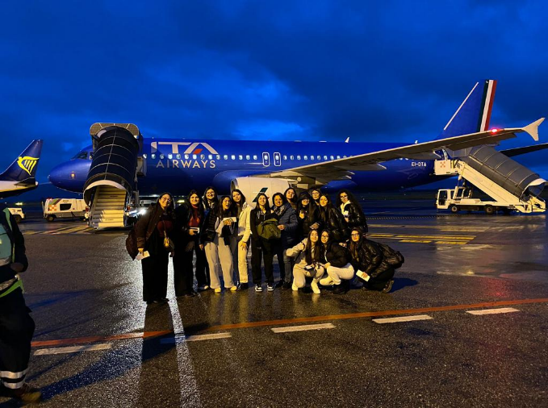

The next day,in the morning, we stayed at school and started working on the group project.
In the afternoon we visited the city of Izegem and some of its churches.
In the afternoon we went to Ypres; here we had the opportunity to visite Tyne Cot, the biggest cemetery in honor of those who died during the First World War. We walked among the graves and also saw an event in honor of the war dead, the Last Post.

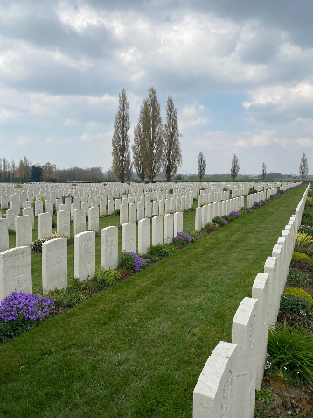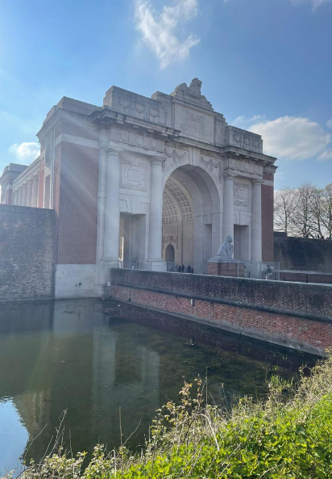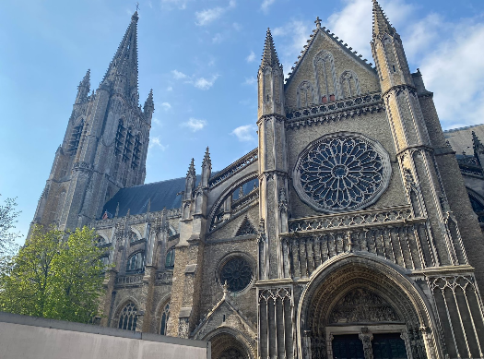
On Wednesday we stayed at school and continued to work on creating some photobooks about the places visited.
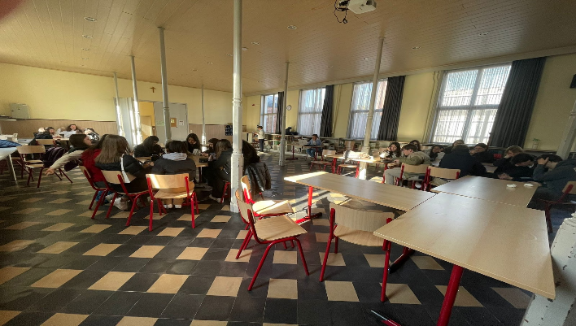

The following day, in the morning, in Izegem we visited a museum of brushes and shoes called Epron d’Or; in the afternoon we took a walk in the parks of the city.
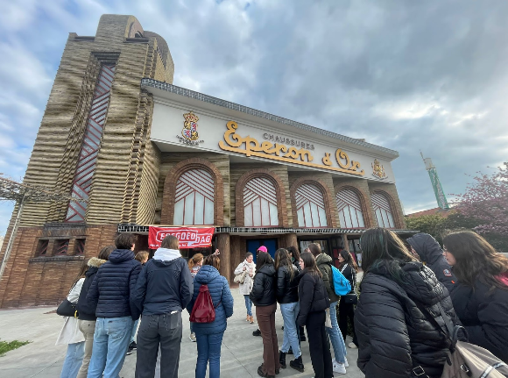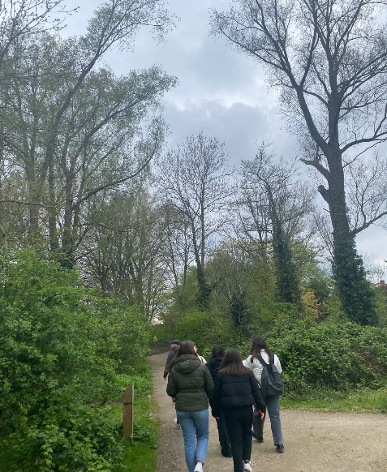

On Friday we visited Bruges, also known as ‘Venice of the North’. We had the opportunity to take a boat tour along its numerous canals.
In the afternoon we went to Ostenda, a coastal city and walked on the pier.

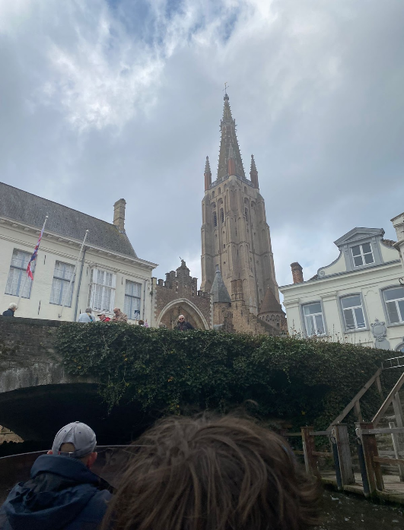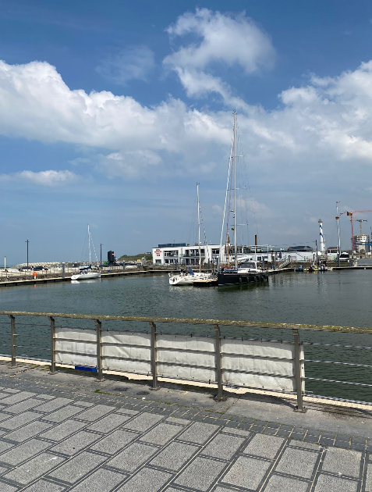

We spent Saturday and Sunday with our host families because in Belgium there’s no lesson during the week end.

The last day, on Monday, we went to school to finish our projects. Unfortunately after lunch we had to say goodbye to all our friends with which we had shared this amazing experience. We met very nice people who will always be in our heart.
At the station, the greetings were touching: it was time to leave.

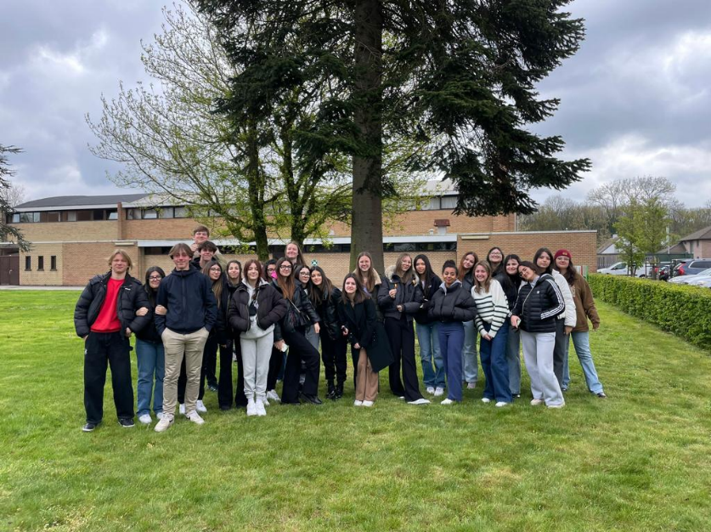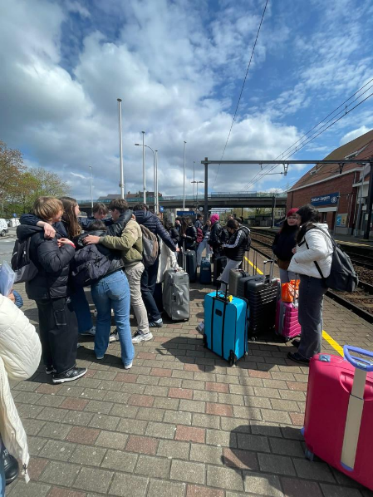

This project allowed us to visit new places but above all to interact with our peers, opening up to new cultures and new lifestyles. It helped us to grow, to enrich our knowledge, to understand the importance of the English language because, for the first time, we spoke in a foreign language all days.
We would like to thank our head techer Teresa Agosto, our school project referent Mrs Marinella Prospero, and a special thank you to Mrs Angela Mancuso and Mrs Mara Vigna who shared with us this wonderful week.

Aiello Miriam, Cavallaro Sofia, Costa Kenya, Lagonia Sara, Violi Angela Rita.

Classe III sez. B Liceo delle Scienze Umane indirizzo Economico - Sociale

