ERASMUS PLUS 2016

In-service training in Ljubljana July 10 – 15, 2016
“PREVENTING EARLY SCHOOL LEAVING AND TEACHING CREATIVITY”
PREMESSA
Gli esseri umani imparano facendo connessioni. A livello biologico, le connessioni avvengono tra neuroni, i quali s’ingrandiscono man mano che si vivono nuove esperienze. A livello mentale, le connessioni formano concetti, nel momento in cui associamo un’idea con un’altra, memorizzando o sperimentando relazioni tra oggetti e azioni. A livello sociale, le connessioni prendono la forma di conversazioni quando incontriamo gente e condividiamo idee. Non è necessario impegnarsi per realizzare connessioni, esse avvengono naturalmente, così come non possiamo evitare di apprendere: lo facciamo continuamente.
E allora perché in molti casi sembra così difficile apprendere, tanto che l’insuccesso scolastico da demotivazione diventa dispersione? Probabilmente il processo insegnamento-apprendimento non segue il percorso naturale “curiosità-scoperta-condivisione-memorizzazione” ma parte dalla fine: “memorizzazione” di fatti o concetti disconnessi dal precedente stato cognitivo-metacognitivo-esperienziale del discente.
Il corso di formazione a Lubiana, nell’ambito del programma ErasmusPlus 2016, sulla prevenzione della dispersione e l’insegnamento della creatività, mirando alla sollecitazione della motivazione tramite gli stimoli indirizzati alle abilità del pensiero, è stato illuminante per aver aperto nuovi orizzonti pedagogici e nuove pratiche didattiche, più attive, coinvolgenti, partecipate.
La lezione frontale e trasmissiva cede il posto al brain storming continuo, alla ricerca-azione, al compito significativo, al problem solving, alla costruzione di un percorso di apprendimento, condiviso e sociale.
Principio ispiratore dell’innovazione didattica è il metodo DE BONO. De Bono è l L’inventore del termine "pensiero laterale" e l'ideatore del Programma di Pensiero CoRT (Cognitive research trust) per le scuole, programma utilizzato a livello internazionale per l'insegnamento delle abilità di pensiero.
Con il termine pensiero laterale, Edward de Bono intende una modalità di risoluzione di problemi logici secondo un approccio indiretto ovvero l'osservazione del problema da diverse angolazioni, contrapposta alla tradizionale modalità che prevede la concentrazione su una soluzione diretta al problema.

Mentre una soluzione diretta si fonda sulla logica sequenziale, risolvendo il problema partendo dalle considerazioni che sembrano più ovvie, il pensiero laterale, invece, se ne discosta (da cui il termine laterale) e cerca punti di vista alternativi prima di arrivare alla soluzione.
Il principio che sta alla base di questa procedura è quello per cui è sempre possibile individuare diverse soluzioni di un problema, alcune delle quali emergono solo:
- prescindendo da quello che inizialmente appare l'unico percorso possibile
- cercando elementi, idee, intuizioni, spunti fuori dal dominio di conoscenza e dalla rigida catena logica.
È importante quindi disporre di modalità e strumenti che facilitino questi processi di pensiero, per generare creativamente ipotesi da abbinare e combinare con le conoscenze già possedute, fino al raggiungimento dell'obiettivo prefissato. È il caso delle mappe creative, che consentono al contempo di fermare le idee e di registrarle, predisponendole per essere poi rielaborate. Tra queste si collocano anche le mappe mentali oppure le solution maps.
L’innovazione della pratica didattica che può discendere dall’applicare il metodo De Bono, risiede nella possibilità per il docente di presentare contenuti disciplinari da un’altra angolazione. Non più quella dalla prospettiva della lezione frontale ma dal di dentro dell’argomento , facendolo esplorare e scoprire e ricostruire dagli studenti. Lungo il percorso, mentre si procede nella ricerca significativa di concetti, informazioni, dati, trasversalmente, si sollecitano le abilità del pensiero e della vita. Nella complessità del mondo odierno, educare a pensare e a pensare per innovare, è fondamentale e deve essere trasversalmente praticato in ogni disciplina. Il pensiero creativo è la competenza primaria delle nuove generazioni, poiché esercitando le Life Skills esercitiamo la persona a diventare capace di trasformare le conoscenze, gli atteggiamenti ed i valori in reali capacità, cioè a sapere cosa fare e come farlo.

ATTIVITA’ DIDATTICA 1

Topic | New Technologies
Aim | Development of the critical thinking  Focus on the processes involved in being rational.  These processes include:  • analyzing arguments;  • judging the relevance and significance of information;  • evaluating claims, inferences, arguments and explanations;  • constructing clear and coherent arguments;  • forming well-reasoned judgments and decisions.  Being rational also requires an open-minded yet critical approach to one’s own thinking as well as that of others.  • Critical Thinking is based around the concept of argument. Students learn to recognize when someone is engaged in reasoned argument, as distinct from quarrelling, disputing, reporting or explaining.  Different examples of reasoning and argument are explored to understand their common characteristics, and most importantly the use of reasons (or premises) to support conclusions.  • Students learn a basic language of reasoning: everyday words such as ‘therefore’, ‘because’, ‘if…then’, which are used in arguments; and semi-technical terms such as ‘conclusion’, ‘assumption’, ‘statement”, “consequently” which are used to talk about argument.
Age / class | 15-16 years old-3rd class
Level | B1
Time | 2 hours
Materials | Written text  Interactive whiteboard
Introduction

Main activities | The main activities of Critical Thinking are analysis, evaluation and construction of argument.  -By analyzing arguments, students learn to identify the key parts of a reasoned case, and to understand how they work.  -To evaluate a piece of reasoning, students need to make informed judgments about how sound, strong or weak it is. This often includes assessing the impact of responses to an argument: challenges,  Supporting evidence, counter-examples, etc.  -At the end students construct their own reasoning, based on stimulus material.
Procedure | 1 listening to the text  2 reading the text  3 giving the unknown vocabulary  4 discovering the main reasons in each paragraphs (speaking activity)  5 looking for information-examples of the author supporting reasons (speaking activity)  6 creating a table (writing activity-digital activity)  7 constructing your own argument and expressing your own evaluation (speaking activity and sharing opinions with the others)

Text
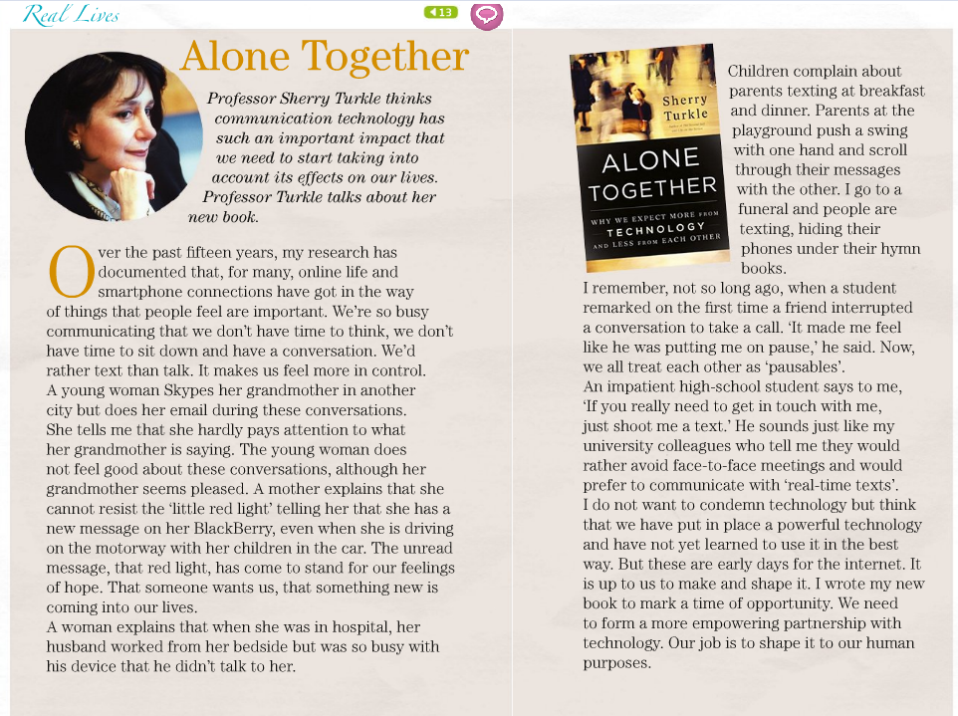

Questions

Which is the main argument?
- Communication technology makes our relations with other people better.
- Communication technology can be bad for us and we need to learn how to use it better
- We should stop using communication technology because it is bad for use

BUILD A TABLE
Main argument
Communication technology can be bad if we don’t learn how to use it better
Reasons | Information and examples supporting them
1 communication technologies can be addictive | A woman cannot resist when the red light or a sound show a new message
2 communication technology is bad for relationships between people: we’ d rather text than talk | A young woman skypes her grandmother but does her emails during those conversations and she hardly pays attention to what her grandmother says
3 the unreal world of technologies supports our hopes | The sound of a message tells us that someone wants us, that something new is happening
4 we keep on using mobiles and we don’t pay attention to what we are doing at the moment | -a woman explains that when she was at the hospital her husband worked at her bedside but was so busy with his device that he didn’t talk to her  -children complains about parents texting at breakfast and dinner
5 communication technology interrupt real life communication | We all treat each other as “pausables”
6 the author does not condemn communication technology | We need just to learn how to use it in a better way, our job is to shape it to our human purposes

Construct your own argument- express your own evaluation- share and report other schoolmates’ ideas.

ATTIVITA’ DIDATTICA 2

PROJECT BASED LEARNING
Topic
Refugees
Aims
• To promote cross-cultural understanding and tolerance
• To encourage planning, collaboration and team work
• To raise awareness of World Refugee Day
• To give pupils an opportunity to be creative
• To develop presentation skills
Age group
Young learners aged 14
Level
CEF Level B1 and above
Time
50 - 60 minutes
Materials
Refugee Project worksheet (1 per pupil)
Optional: access to a classroom computer
Project materials: coloured pens, pencils or crayons, paper, a large sheet of card, scissors, glue
Introduction
Since 2001, the United Nations has designated June 20th as World Refugee Day, Dedicated to raising awareness of the situation of refugees throughout the world.
In this lesson, pupils learn what a refugee is by reading a definition, some statistics and some information about how refugees might feel. The text is sensitive and does not mention any specific group. Students are encouraged to put themselves in the place of a refugee and consider how they might feel at leaving behind their homes and belongings. They can also watch a short video produced by UNICEF, in which two brothers talk about their journey from Syria to Germany.
In the main part of the lesson students work in groups to produce a poster presentation. They imagine a group of refugee children of the same age are coming to live in their town. Then follow clear steps to plan, research, prepare, do and present ideas for activities to make the refugees feel welcome. Finally they present their ideas to the class using posters to help them explain their ideas.
Procedure
Before the lesson
Download and make copies of the worksheets you need for the lesson.

1.Warmer (3 – 5 minutes)
If appropriate, explain that June 20th is World Refugee Day. Write refugee on the board and ask students if they know what it means. Accept any ideas at this stage.
2. Checking understanding (10 minutes)
Give each student a copy of the Refugee Project Worksheet.
Students do activity 1. They read the text about refugees and answer the question
(orally or in writing).
Check students’ understanding by asking a few comprehension questions:
Why do refugees leave their country? What do they leave behind? What’s the
difference between travelling to another country for a holiday and being a refugee?
3. Video viewing
(10 – 15 minutes)
To help students develop a deeper understanding of the refugee crisis, you could
show them the UNICEF video ‘From Syria to Germany: A tale of two brothers’. The
language level of the video is aimed at CEF level B2 learners so some of the
language will be challenging. However, the LearnEnglish Teens website has a
series of exercises to help comprehension.
Link to video and exercises: https://learnenglishteens.britishcouncil.org/studybreak/
video-zone/tale-two-brothers
3. Project preparation (5 – 8 minutes)
Students read activity 2 (a description of the project).
Put students into groups of 4. If you think it is helpful, appoint the following roles
within each group:
Student A: Note-taker (writes down initial ideas).
Student B: Organiser (organises the group and the materials).
Student C: English monitor (reminds students to use as much English as possible).
Student D: Time-keeper (decides how much time needs to be spent on each step
and then makes sure times are adhered to.
4. Project work (30 minutes)
Students follow steps 1-6 of their projects
5. Presentations (10 – 15minutes)
Students take turns to present their ideas to the class (step 6).
6. Optional filming
Film students’ presentations (with parents’ permission) and play back the recordings in the next lesson.
Prof.ssa Cristina Lupia

