Plan of learning activities during the group mobility in
Catanzaro- ITALY
27 Febbraio – 6 Marzo 2023

Monday 27/02/2023

- Arrival at Lamezia Terme airport at 20:00
- Evening in the host family
Tuesday 28/02/2023
Istituto di Istruzione Superiore “E. Fermi”, viale Crotone S.N.C. Catanzaro
- 8:30 Greetings and official welcoming by the school authorities in the Auditorium Scopelliti
- 8:45 Visit of the school
- 9:15 Presentation of the program
- Working groups
- 13:00 Lunch
- 14:00 Discovering Catanzaro Lido: walk along the seafront 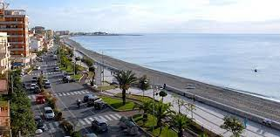
- Evening in the host family
Wednesday 1 /03/ 2023
- 8:15 Departure for Reggio Calabria by bus: visit to the Museo Archeologico Nazionale, stroll along the seafront, known as Italy’s most beautiful kilometre

- 13:00 Lunch at MacDonald’s
- 15:00 Visit to Pizzo and tasting of its famous «tartufo» ice-cream
- Evening in the host family
Thursday 2 /03/ 2023
- 8:15 Group work at school
- Lunch break
- 11:15 Departure for Capo Colonna and Le Castella by bus discovering the Ionian coast
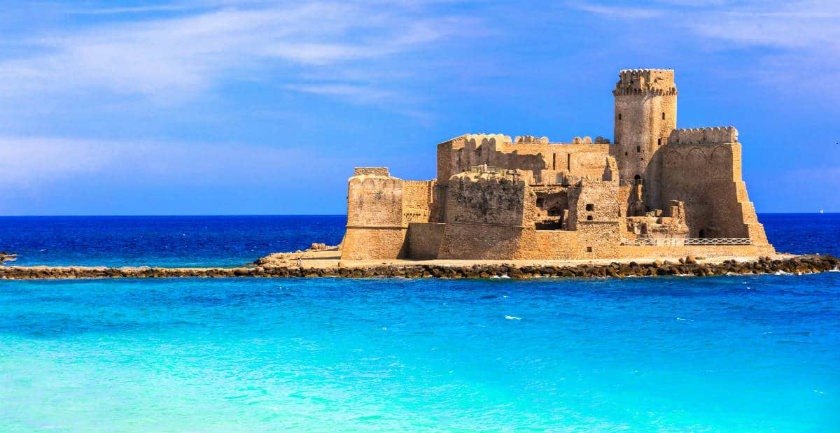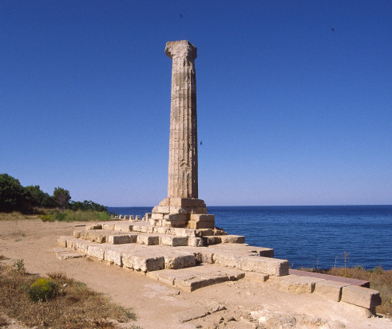

- Evening with the host famiy
- 8:15 Teamwork at school
Friday 3 /03/ 2023
- 13:00 Lunch break
- 14:30 Visit to Catanzaro Lido
- Evening with the host family

Saturday 4 /03/ 2023

- 8:15 Departure to the Museo and Parco Archeologico Nazionale of Scolacium (Roccelletta di Borgia by bus 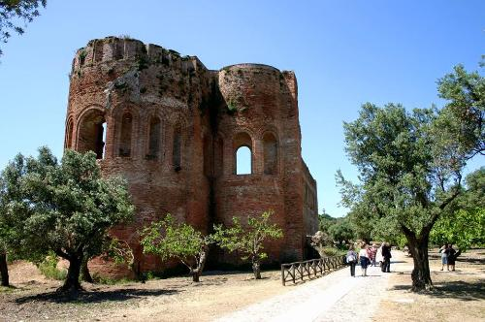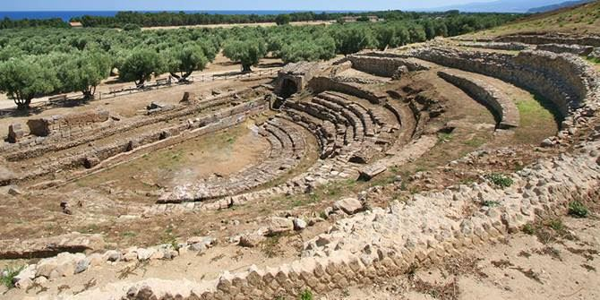

- 10:15 Departure to the city of Catanzaro by bus: visit to the Parco della Biodiversità (Museo Storico Militare (MUSMI), il Cavatore, Chiesa di San Giovanni, terrazza panoramica del complesso monumentale del S. Giovanni.

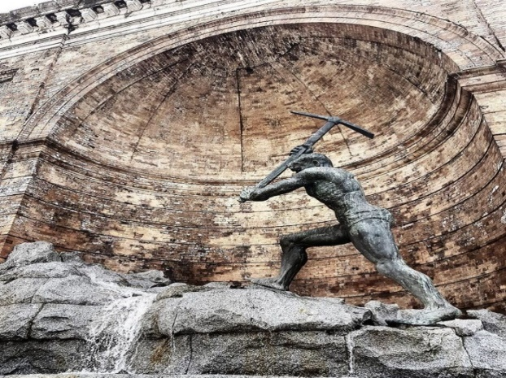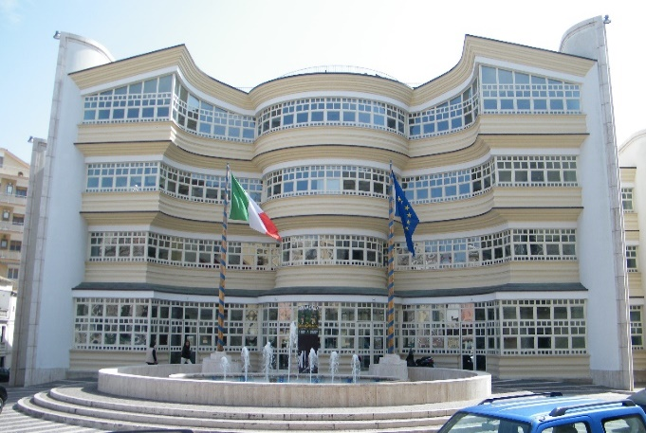

- 13:00 Lunch break at “Amedeo’s”
- 15:00 Visit of the historical centre of the city: Palazzo Fazzari, Basilica dell’ Immacolata Teatro Politeama , Villa Margherita, belvedere Bellavista
- Evening in the host family

Sunday 5 /03/ 2023

- Full day with the host families

Monday 6 /03/ 2023

- 8:15 Morning at school: evaluation of the experience and goodbye greetings
- Departure of the group

