Business Idea
BioRecy

IO3 - OUTSIDE Green Business Collection

Sacco Raoul, Torchia Antonio, Gregorace Giuseppe, Mancuso Jacopo, Talotta Mariagiovanna, Gentile Noemi, Scumaci Pasquale, Settembrino Antonio Pio, Rotundo Sidney, Mancuso Sharon - CLASSE IV G

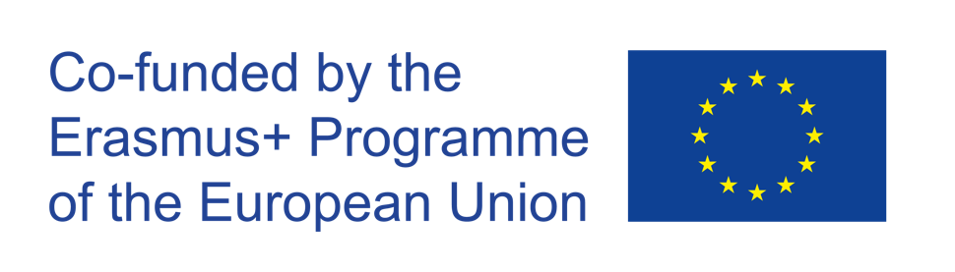

The European Commission's support for the production of this publication does not constitute an endorsement of the contents, which reflect the views only of the authors, and the Commission cannot be held responsible for any use which may be made of the information contained therein.
Project: “OUTSIDE- Open commUniTies for SustaInable DevelopmEnt” Nr. 2020-1-IT02-KA201-079803

Introduction

OUTSIDE is a European project funded by the Erasmus+ Programme (Key Action 2 –Cooperation for Innovation and Exchange of Good Practices). The duration of the project is of 30 months, from October 1st 2020to March 31st 2023. OUTSIDE is implemented by 5 European Countries (Italy, Belgium, Croatia, Lithuania, UK). The Partnership is made up of 5 Schools and 4 Organizations active in the field of sustainable development & entrepreneurship. OUTSIDE has the general objective to promote the acquisition of key and innovative competences among students, through the creation of entrepreneurial projects in the field of sustainability.

In each piloting country, partners will be responsible for the organization of training groups of students aged 11-17 that will deliver at least 3 green projects per country (Intellectual Output 3).

Title of the business idea: Classe IV G - BioRecy

Description  Link to the OUTSIDE Toolkit: Module 4 Session 4: Development of a green business idea | Our business idea is focused on waste recycling. It consists of the foundation of a series of certified stores suitable for offering free gifts (food or organic) in exchange for waste to be recycled. The people we target most are entrepreneurs and large companies, due to the large presence of such raw material, but the target expands to the whole population, which in its own small way can contribute to our success. Our goal is to decrease waste thrown away unnecessarily by offering a better opportunity to be exploited (getting a free gift in return), in order to educate about the preservation of the planet. We aim for the opening of our business in a short time, a few months, just enough time to organize the network of stores and collaborators, so that we can achieve our goal in a couple of years. We think it can work because customers do not have to buy anything, they simply have to bring something they already own that would go to waste, to get a free gift. Our business will be located around Catanzaro Lido; it will be developed through the support of a number of local collaborators useful to our cause. The main problem we aim to solve is the excessive amount of waste thrown unnecessarily, on the streets, in the woods, a reason for great pollution.
The local environmental challenge  Link to the OUTSIDE Toolkit: Module 4 Session 3: Mapping local environmental challenges | The main problem we aim to solve is the excessive amount of waste thrown unnecessarily, on the streets, in the woods, a reason for great pollution. In fact, we must admit that such environmental discomfort is only our fault, our indolence and selfishness, thinking that a single person cannot make an already toxic situation worse. It is necessary to move people, to convince them of the existence of an alternative solution, we aim to be this, offering a gift in exchange for the help of the people.
Skills  Link to the OUTSIDE Toolkit: Module 7  Session 2: how to create and run sustainable team  Session 4: how to boost internal and external communication skills of the team | The main ability of our company is to have zero costs. In addition, in order to facilitate adequate reception even for customers from abroad, our staff possesses knowledge of at least two languages, among which is English, which is recognized as an international language. An additional strength is the possession of adequate computer skills that facilitate the company in the organizational and administrative field. As for the propaganda of our image, a good part of our staff possesses excellent graphic skills aimed at improving the aesthetic appearance of our company. As for the knowledge we need, it mainly concerns the economic-financial sphere. In fact, compulsorily we will have to work with a competent figure in this area, who will manage the monetary organization and, through a series of researches and analyses, bring about improvements and reductions in the company's costs. Next, the figure of the accountant is also needed. Finally, figures skilled in storage also prove essential for waste storage.
Resources  Link to the OUTSIDE Toolkit: Module 3 Session 2: Mapping and connecting with the external community | Our team has a range of internal and external resources that can be used. As for internal resources, we are able to take care of the graphics, advertising and accounting side by relying on a qualified economist. In addition, we can contribute as store clerks by leaning on a number of warehouse workers and qualified staff. As for external resources, we rely on a recycling company and a number of local agricultural producers.
Financial planning  Link to the OUTSIDE Toolkit: Module 7  Session 1: getting started with project management  Session 3: how to manage a green project | The financial aspect of our business idea strikes an excellent balance between necessary costs and receipts. Regarding the first aspect, we take into consideration the cost for qualified personnel, which is necessary for a good organization. Second are the costs for electricity, facility services (air conditioning, etc...) and storage costs. Also necessary are those for advertisements and the purchase of food or plant-based products. As for income, we derive the main ones from the sale of waste to recycling companies. In addition, home pickup of waste is possible at a due cost, which is frequent in the case of large companies. Finally, we will have the possibility of buying products in bulk or supply from local producers, reducing costs.
Green Business Model Canvas  Link to the OUTSIDE Toolkit: Module 7  Session 3: Developing a green business model canvas | 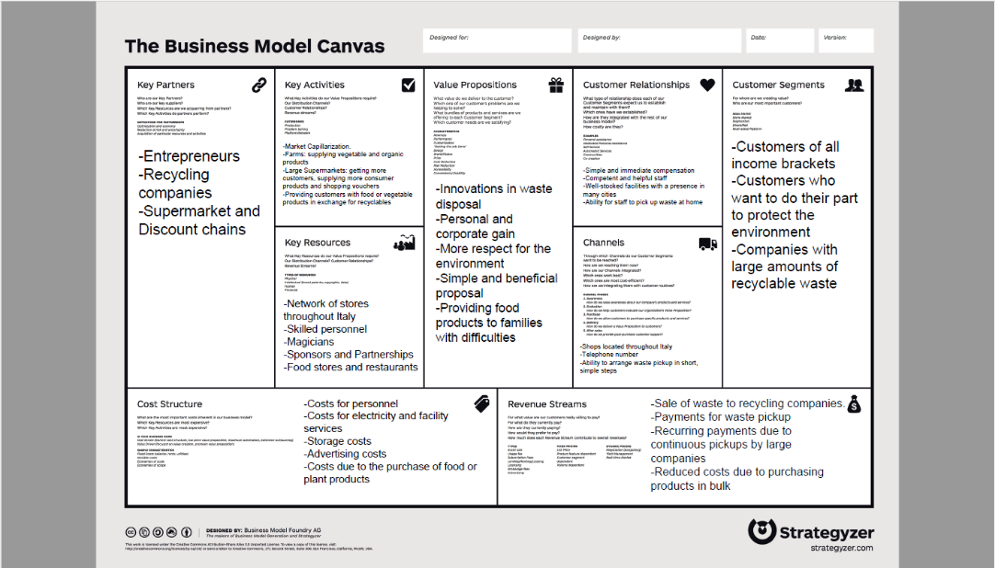
Possible impact | Our business can certainly make significant changes in society. First, food items will be more present for the people, this would decrease hunger in small local communities through helping less well-off families. Secondly, it would improve the state of cleanliness of the villages, which will present less waste, becoming more pleasant to visit. Finally, it would urge the population to pollute less, thanks to the presence of a free gift
Marketing and product pitch  Link to the OUTSIDE Toolkit: Module 8  Session 2: Utilizing the digital skills and social media to boost business ideas  Session 3: Making Social Media strategy to boost green business ideas | To promote our business idea, we are relying mainly on a network of sponsors and advertising, with the help of local stores that could help grow our reputation. Obviously in small towns word of mouth will be very helpful, however, for the capillarization of our market, the support of a number of major companies willing to sponsor our business is necessary.
Space for the pictures and videos | 